**Technical Document: Shortest Optimal Route Pathfinding**

This technical document provides an overview and documentation for the code implementing the shortest optimal route pathfinding using Dijkstra's algorithm. The code is written in Python and aims to find the shortest path between two points on a map represented as a graph.

**Algorithm Description**

The implemented algorithm follows these main steps:

1. **Dijkstra's Algorithm**: The **dijkstra** function calculates the shortest distances from a given start location to all other locations in the graph. It initializes a dictionary called **distances** with all distances set to infinity except for the start location, which is set to 0. A priority queue, implemented as a heap, called **queue** is used to track the nodes to visit. The algorithm repeatedly selects the node with the smallest distance from the queue, updates the distances to its neighbors if a shorter path is found, and continues until all nodes have been visited or the queue is empty.
2. **Path Reconstruction**: The **shortest_path** function utilizes the **distances** dictionary obtained from Dijkstra's algorithm to reconstruct the shortest path from the start location to the end location. It starts from the end location and iteratively backtracks to the start location by selecting the neighbor with a distance that matches the current node's distance minus the edge weight. The resulting path is stored in a list, which is then reversed to obtain the correct order.

**Code Usage**

To use the provided code, follow these steps:

1. Define the map as a graph: The graph should be represented as a dictionary, where the keys represent the locations and the values are dictionaries representing the connections from each location to its neighbors, along with their corresponding weights (distances).
2. Call the **shortest_path** function: Provide the graph, start location, and end location as input parameters to the **shortest_path** function. It will return the shortest path as a list of locations.
3. Access the shortest path: The resulting shortest path will be stored in a list. You can access and utilize it according to your specific requirements.

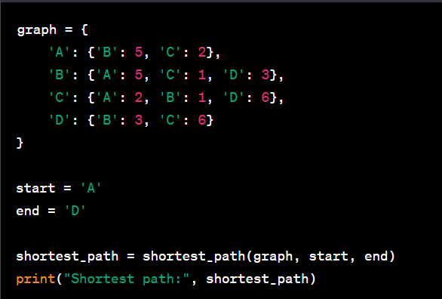**Example**

Here's an example usage of the code:

pythonCopy code

graph = { 'A': {'B': 5, 'C': 2}, 'B': {'A': 5, 'C': 1, 'D': 3}, 'C': {'A': 2, 'B': 1, 'D': 6}, 'D': {'B': 3, 'C': 6} } start = 'A' end = 'D' shortest_path = shortest_path(graph, start, end) print("Shortest path:", shortest_path)

This example demonstrates the usage of the code by defining a graph representing a map with four locations (A, B, C, and D) and their connections. The start location is set to 'A' and the end location to 'D'. The resulting shortest path is then printed, which provides the sequence of locations to follow to reach the destination using the shortest optimal route.

**Conclusion**

The provided code offers a straightforward implementation of the shortest optimal route pathfinding using Dijkstra's algorithm. By inputting a graph representation of a map and specifying the start and end locations, the code efficiently calculates and returns the shortest path between the given points. It can be further extended and customized to accommodate additional features or constraints based on specific use cases and requirements.

Top of Form